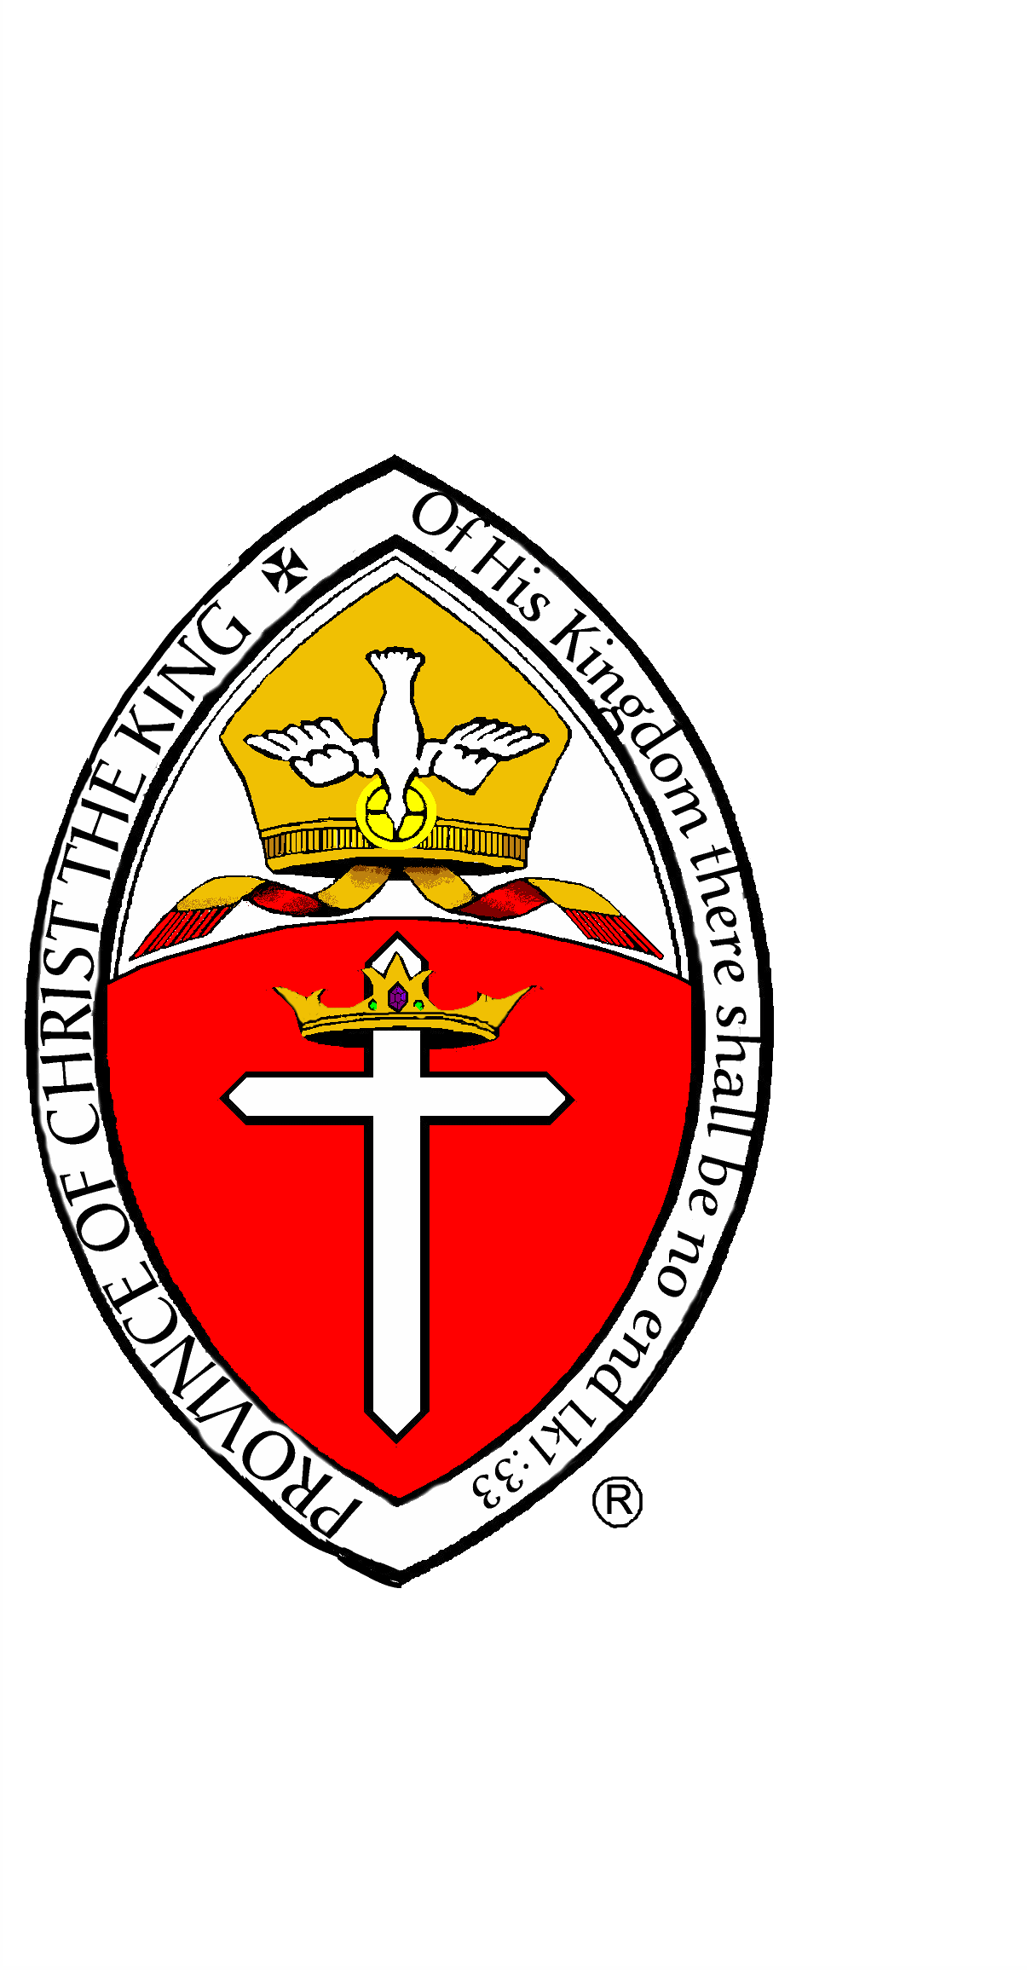The Anglican Province of Christ the King

St. George’s Anglican Pro-Cathedral

1210 Dixie Trail

Raleigh, NC 27614

(919) 786-0640

Archiepiscopal Residence:

10317 Crisp Drive

Raleigh, NC 27614

[APCKArchbishopJEU@hotmail.com](mailto:APCKArchbishopJEU@hotmail.com)

A Pastoral Letter to be Read in the Churches

Sunday, October 31st, AD 2021

October 29th, AD 2021

Dear Brothers and Sisters in Christ:

I am writing to let you know I am having one last surgery to eradicate my cancer on Friday morning, November 5th, AD 2021 and I ask for your prayers for a successful surgery and a speedy recovery. I am looking forward to being cancer-free and getting on the road to recovery so I can get back to my duties and responsibilities to you as soon as possible.

I also want to let you know how much Mrs. Upham and I have appreciated all your cards and gestures of good-will, especially the food cards with which to order food in. They are very handy and very useful.

I have been told by my surgeon that I will be in the hospital about seven days and then healing at home for six to eight weeks. Please keep Mrs. Upham and me in your prayers and I hope to be out and about by the first of the year.

I wish you all a joyful Christ the King Sunday and a blessed All Hallowstide.

In Christ,

Archbishop Upham